Preparation of Papers for WWRF Meetings
First A. Author, Second B. Author, Jr., and Third C. Author
Abstract—These instructions give you guidelines for preparing papers for WWRF conference papers. Use this document as a template if you are using Microsoft Word 6.0 or later. Otherwise, use this document as an instruction set. Define all symbols used in the abstract. Do not cite references in the abstract. The paper should not exceed 10 pages.

Index Terms—About four key words or phrases in alphabetical order, separated by commas. For a list of suggested keywords visit the IEEE web site at http://www.ieee.org/organizations/pubs/ani_prod/keywrd98.txt

INTRODUCTION
THIS document is a template for Microsoft Word versions 6.0 or later.
When you open WWRF-TEMPLATE.DOC, select “Page Layout” from the “View” menu in the menu bar (View | Page Layout), which allows you to see the footnotes. Then type over sections of WWRF-TEMPLATE.DOC or cut and paste from another document and then use markup styles. The pull-down style menu is at the left of the Formatting Toolbar at the top of your Word window (for example, the style at this point in the document is “Text”). Highlight a section that you want to designate with a certain style, then select the appropriate name on the style menu. The style will adjust your fonts and line spacing. Do not change the font sizes or line spacing to squeeze more text into a limited number of pages. Use italics for emphasis; do not underline.
To insert images in Word, position the cursor at the insertion point and either use Insert | Picture | From File or copy the image to the Windows clipboard and then Edit | Paste Special | Picture (with “Float over text” unchecked).

Procedure for Paper Submission

Review Stage
Please check with your editor on whether to submit your manuscript by hard copy or electronically for review. If hard copy, submit photocopies such that only one column appears per page. This will give your referees plenty of room to write comments. Send the number of copies specified by your editor (typically four). If submitted electronically, find out if your editor prefers submissions on disk or as e-mail attachments.
If you want to submit your file with one column electronically, please do the following:
--First, click on the View menu and choose Print Layout.
--Second, place your cursor in the first paragraph. Go to the Format menu, choose Columns, choose one column Layout, and choose “apply to whole document” from the dropdown menu.
--Third, click and drag the right margin bar to just over 4 inches in width.
The graphics will stay in the “second” column, but you can drag them to the first column. Make the graphic wider to push out any text that may try to fill in next to the graphic.

Final Stage
You must also send your final manuscript (when accepted) electronically to the WG chair only. Use Zip format for compression if necessary.

Electronic Image Files (Optional)
You will have the greatest control over the appearance of your figures if you are able to prepare electronic image files. If you do not have the required computer skills, just submit paper prints as described above and skip this section.
1) Easiest Way: If you have a scanner, the best and quickest way to prepare noncolor figure files is to print your tables and figures on paper exactly as you want them to appear, scan them, and then save them to a file in PostScript (PS) or Encapsulated PostScript (EPS) formats. Use a separate file for each image. File names should be of the form “fig1.ps” or “fig2.eps.”
2) Slightly Harder Way: Using a scanner as above, save the images in TIFF format. High-contrast line figures and tables should be prepared with 600 dpi resolution and saved with no compression, 1 bit per pixel (monochrome), with file names of the form “fig3.tif” or “table1.tif.” To obtain a 3.45-in figure (one-column width) at 600 dpi, the figure requires a horizontal size of 2070 pixels. Typical file sizes will be on the order of 0.5 MB.
Photographs and grayscale figures should be prepared with 220 dpi resolution and saved with no compression, 8 bits per pixel (grayscale). To obtain a 3.45-in figure (one-column width) at 220 dpi, the figure should have a horizontal size of 759 pixels.
Color figures should be prepared with 400 dpi resolution and saved with no compression, 8 bits per pixel (palette or 256 color). To obtain a 3.45-in figure (one column width) at 400 dpi, the figure should have a horizontal size of 1380 pixels.
For more information on TIFF files, please go to http://www.ieee.org/organizations/pubs/transactions/information.htm and click on the link “Guidelines for Author Supplied Electronic Text and Graphics.”
3) Somewhat Harder Way: If you do not have a scanner, you may create noncolor PostScript figures by “printing” them to files. First, download a PostScript printer driver from http://www.adobe.com/support/downloads/pdrvwin.htm (for Windows) or from http://www.adobe.com/support/downloads/ pdrvmac.htm (for Macintosh) and install the “Generic PostScript Printer” definition. In Word, paste your figure into a new document. Print to a file using the PostScript printer driver. File names should be of the form “fig5.ps.” Use Adobe Type 1 fonts when creating your figures, if possible.
4) Other Ways: Experienced computer users can convert figures and tables from their original format to TIFF. Some useful image converters are Adobe Photoshop, Corel Draw, and Microsoft Photo Editor, an application that is part of Microsoft Office 97 and Office 2000 (look for C:\Program Files\Common Files \Microsoft Shared\ PhotoEd\ PHOTOED.EXE. (You may have to custom-install Photo Editor from your original Office disk.)
Here is a way to make TIFF image files of tables. First, create your table in Word. Use horizontal lines but no vertical lines. Hide gridlines (Table | Hide Gridlines). Spell check the table to remove any red underlines that indicate spelling errors. Adjust magnification (View | Zoom) such that you can view the entire table at maximum area when you select View | Full Screen. Move the cursor so that it is out of the way. Press “Print Screen” on your keyboard; this copies the screen image to the Windows clipboard. Open Microsoft Photo Editor and click Edit | Paste as New Image. Crop the table image (click Select button; select the part you want, then Image | Crop). Adjust the properties of the image (File | Properties) to monochrome (1 bit) and 600 pixels per inch. Resize the image (Image | Resize) to a width of 3.45 inches. Save the file (File | Save As) in TIFF with no compression (click “More” button).
Most graphing programs allow you to save graphs in TIFF; however, you often have no control over compression or number of bits per pixel. You should open these image files in a program such as Microsoft Photo Editor and re-save them using no compression, either 1 or 8 bits, and either 600 or 220 dpi resolution (File | Properties; Image | Resize). See Section II-D2 for an explanation of number of bits and resolution. If your graphing program cannot export to TIFF, you can use the same technique described for tables in the previous paragraph.
A way to convert a figure from Windows Metafile (WMF) to TIFF is to paste it into Microsoft PowerPoint, save it in JPG format, open it with Microsoft Photo Editor or similar converter, and re-save it as TIFF.
Microsoft Excel allows you to save spreadsheet charts in Graphics Interchange Format (GIF). To get good resolution, make the Excel charts very large. Then use the “Save as

HTML” feature (see http://support.microsoft.com/support/ kb/articles/q158/0/79.asp). You can then convert from GIF to TIFF using Microsoft Photo Editor, for example.
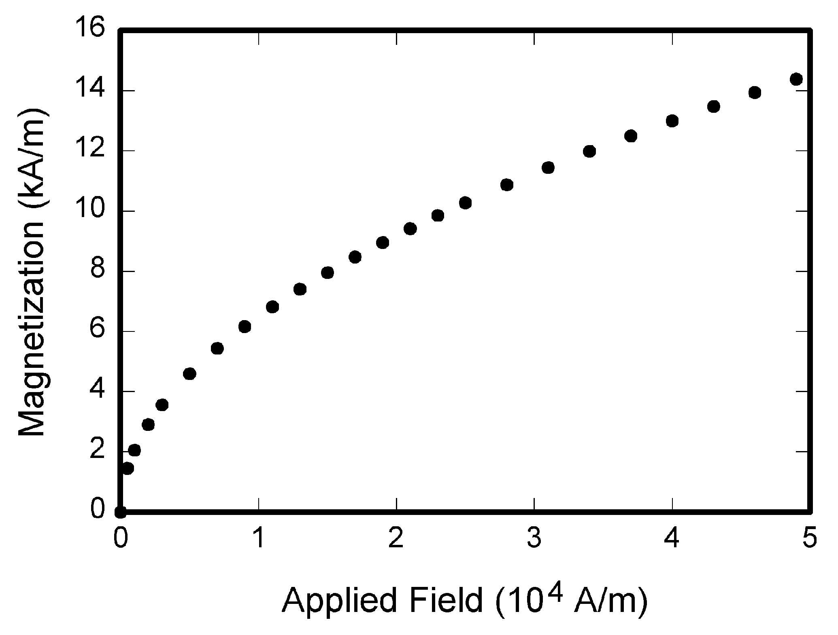
Fig. 1. Magnetization as a function of applied field. Note that “Fig.” is abbreviated. There is a period after the figure number, followed by two spaces. It is good practice to explain the significance of the figure in the caption.

No matter how you convert your images, it is a good idea to print the TIFF files to make sure nothing was lost in the conversion.
If you modify this document for use with other IEEE journals or conferences, you should save it as type “Word 97-2000 & 6.0/95 - RTF (*.doc)” so that it can be opened by any version of Word.

Copyright Form
TABLE I
Units for Magnetic Properties
Symbol | Quantity | Conversion from Gaussian and  CGS EMU to SI ª
Φ | magnetic flux | 1 Mx → 10⁻⁸ Wb = 10⁻⁸ V·s
B | magnetic flux density,  magnetic induction | 1 G → 10⁻⁴ T = 10⁻⁴ Wb/m²
H | magnetic field strength | 1 Oe → 10³/(4π) A/m
m | magnetic moment | 1 erg/G = 1 emu  → 10⁻³ A·m² = 10⁻³ J/T
M | magnetization | 1 erg/(G·cm³) = 1 emu/cm³  → 10³ A/m
4πM | magnetization | 1 G → 10³/(4π) A/m
σ | specific magnetization | 1 erg/(G·g) = 1 emu/g → 1 A·m²/kg
j | magnetic dipole  moment | 1 erg/G = 1 emu  → 4π × 10⁻¹⁰ Wb·m
J | magnetic polarization | 1 erg/(G·cm³) = 1 emu/cm³  → 4π × 10⁻⁴ T
χ, κ | susceptibility | 1 → 4π
χ_{ρ} | mass susceptibility | 1 cm³/g → 4π × 10⁻³ m³/kg
μ | permeability | 1 → 4π × 10⁻⁷ H/m  = 4π × 10⁻⁷ Wb/(A·m)
μ_{r} | relative permeability | μ → μ_{r}
w, W | energy density | 1 erg/cm³ → 10⁻¹ J/m³
N, D | demagnetizing factor | 1 → 1/(4π)
No vertical lines in table. Statements that serve as captions for the entire table do not need footnote letters.
ªGaussian units are the same as cgs emu for magnetostatics; Mx = maxwell, G = gauss, Oe = oersted; Wb = weber, V = volt, s = second, T = tesla, m = meter, A = ampere, J = joule, kg = kilogram, H = henry.

An WWRF copyright license transfer form should accompany your final submission. You can get a .doc version at the http:.//www.wireless-world-research.org/meetings folder. Authors are responsible for obtaining any security clearances.

MATH
If you are using Word, use either the Microsoft Equation Editor or the MathType add-on (http://www.mathtype.com) for equations in your paper (Insert | Object | Create New | Microsoft Equation or MathType Equation). “Float over text” should not be selected.

Units
Use either SI (MKS) or CGS as primary units. (SI units are strongly encouraged.) English units may be used as secondary units (in parentheses). This applies to papers in data storage. For example, write “15 Gb/cm² (100 Gb/in²).” An exception is when English units are used as identifiers in trade, such as “3½ in disk drive.” Avoid combining SI and CGS units, such as current in amperes and magnetic field in oersteds. This often leads to confusion because equations do not balance dimensionally. If you must use mixed units, clearly state the units for each quantity in an equation.
The SI unit for magnetic field strength H is A/m. However, if you wish to use units of T, either refer to magnetic flux density B or magnetic field strength symbolized as µ₀H. Use the center dot to separate compound units, e.g., “A·m².”

Helpful Hints

Figures and Tables
Large figures and tables may span both columns. Place figure captions below the figures; place table titles above the tables. If your figure has two parts, include the labels “(a)” and “(b)” as part of the artwork. Please verify that the figures and tables you mention in the text actually exist. Please do not include captions as part of the figures. Do not put captions in “text boxes” linked to the figures. Do not put borders around the outside of your figures. Use the abbreviation “Fig.” even at the beginning of a sentence. Do not abbreviate “Table.” Tables are numbered with Roman numerals.
Color printing of figures is available, but is billed to the authors (approximately $1300, depending on the number of figures and number of pages containing color). Include a note with your final paper indicating that you request color printing. Do not use color unless it is necessary for the proper interpretation of your figures. If you want reprints of your color article, the reprint order should be submitted promptly. There is an additional charge of $81 per 100 for color reprints.
Figure axis labels are often a source of confusion. Use words rather than symbols. As an example, write the quantity “Magnetization,” or “Magnetization M,” not just “M.” Put units in parentheses. Do not label axes only with units. As in Fig. 1, for example, write “Magnetization (A/m)” or “Magnetization (Am⁻¹),” not just “A/m.” Do not label axes with a ratio of quantities and units. For example, write “Temperature (K),” not “Temperature/K.”
Multipliers can be especially confusing. Write “Magnetization (kA/m)” or “Magnetization (10³ A/m).” Do not write “Magnetization (A/m) × 1000” because the reader would not know whether the top axis label in Fig. 1 meant 16000 A/m or 0.016 A/m. Figure labels should be legible, approximately 8 to 12 point type.

References
Number citations consecutively in square brackets [1]. The sentence punctuation follows the brackets [2]. Multiple references [2], [3] are each numbered with separate brackets [1]–[3]. When citing a section in a book, please give the relevant page numbers [2]. In sentences, refer simply to the reference number, as in [3]. Do not use “Ref. [3]” or “reference [3]” except at the beginning of a sentence: “Reference [3] shows ... .” Unfortunately the IEEE document translator cannot handle automatic endnotes in Word; therefore, type the reference list at the end of the paper using the “References” style.
Number footnotes separately in superscripts (Insert | Footnote). Place the actual footnote at the bottom of the column in which it is cited; do not put footnotes in the reference list (endnotes). Use letters for table footnotes (see Table I).
Please note that the references at the end of this document are in the preferred referencing style. Give all authors’ names; do not use “et al.” unless there are six authors or more. Use a space after authors' initials. Papers that have not been published should be cited as “unpublished” [4]. Papers that have been submitted for publication should be cited as “submitted for publication” [5]. Papers that have been accepted for publication, but not yet specified for an issue should be cited as “to be published” [6]. Please give affiliations and addresses for private communications [7].
Capitalize only the first word in a paper title, except for proper nouns and element symbols. For papers published in translation journals, please give the English citation first, followed by the original foreign-language citation [8].

Abbreviations and Acronyms
Define abbreviations and acronyms the first time they are used in the text, even after they have already been defined in the abstract. Abbreviations such as IEEE, SI, ac, and dc do not have to be defined. Abbreviations that incorporate periods should not have spaces: write “C.N.R.S.,” not “C. N. R. S.” Do not use abbreviations in the title unless they are unavoidable (for example, “IEEE” in the title of this article).

Equations
Number equations consecutively with equation numbers in parentheses flush with the right margin, as in (1). First use the equation editor to create the equation. Then select the “Equation” markup style. Press the tab key and write the equation number in parentheses. To make your equations more compact, you may use the solidus ( / ), the exp function, or appropriate exponents. Use parentheses to avoid ambiguities in denominators. Punctuate equations when they are part of a sentence, as in

(1)

Be sure that the symbols in your equation have been defined before the equation appears or immediately following. Italicize symbols (T might refer to temperature, but T is the unit tesla). Refer to “(1),” not “Eq. (1)” or “equation (1),” except at the beginning of a sentence: “Equation (1) is ... .”

Other Recommendations
Use one space after periods and colons. Hyphenate complex modifiers: “zero-field-cooled magnetization.” Avoid dangling participles, such as, “Using (1), the potential was calculated.” [It is not clear who or what used (1).] Write instead, “The potential was calculated by using (1),” or “Using (1), we calculated the potential.”
Use a zero before decimal points: “0.25,” not “.25.” Use “cm³,” not “cc.” Indicate sample dimensions as “0.1 cm × 0.2 cm,” not “0.1 × 0.2 cm².” The abbreviation for “seconds” is “s,” not “sec.” Do not mix complete spellings and abbreviations of units: use “Wb/m²” or “webers per square meter,” not “webers/m².” When expressing a range of values, write “7 to 9” or “7-9,” not “7~9.”
A parenthetical statement at the end of a sentence is punctuated outside of the closing parenthesis (like this). (A parenthetical sentence is punctuated within the parentheses.) In American English, periods and commas are within quotation marks, like “this period.” Other punctuation is “outside”! Avoid contractions; for example, write “do not” instead of “don’t.” The serial comma is preferred: “A, B, and C” instead of “A, B and C.”
If you wish, you may write in the first person singular or plural and use the active voice (“I observed that ...” or “We observed that ...” instead of “It was observed that ...”). Remember to check spelling. If your native language is not English, please get a native English-speaking colleague to proofread your paper.

Some Common Mistakes
The word “data” is plural, not singular. The subscript for the permeability of vacuum µ₀ is zero, not a lowercase letter “o.” The term for residual magnetization is “remanence”; the adjective is “remanent”; do not write “remnance” or “remnant.” Use the word “micrometer” instead of “micron.” A graph within a graph is an “inset,” not an “insert.” The word “alternatively” is preferred to the word “alternately” (unless you really mean something that alternates). Use the word “whereas” instead of “while” (unless you are referring to simultaneous events). Do not use the word “essentially” to mean “approximately” or “effectively.” Do not use the word “issue” as a euphemism for “problem.” When compositions are not specified, separate chemical symbols by en-dashes; for example, “NiMn” indicates the intermetallic compound Ni_{0.5}Mn_{0.5} whereas “Ni–Mn” indicates an alloy of some composition Ni_{x}Mn_{1-x}.
Be aware of the different meanings of the homophones “affect” (usually a verb) and “effect” (usually a noun), “complement” and “compliment,” “discreet” and “discrete,” “principal” (e.g., “principal investigator”) and “principle” (e.g., “principle of measurement”). Do not confuse “imply” and “infer.”
Prefixes such as “non,” “sub,” “micro,” “multi,” and “"ultra” are not independent words; they should be joined to the words they modify, usually without a hyphen. There is no period after the “et” in the Latin abbreviation “et al.” (it is also italicized). The abbreviation “i.e.,” means “that is,” and the abbreviation “e.g.,” means “for example” (these abbreviations are not italicized).
An excellent style manual and source of information for science writers is [9]. A general IEEE style guide, Information for Authors, is available at http://www.ieee.org/organizations/pubs/transactions/information.htm

Conclusion
A conclusion section is not required. Although a conclusion may review the main points of the paper, do not replicate the abstract as the conclusion. A conclusion might elaborate on the importance of the work or suggest applications and extensions.

Appendix
Appendixes, if needed, appear before the acknowledgment.

Acknowledgment
The preferred spelling of the word “acknowledgment” in American English is without an “e” after the “g.” Use the singular heading even if you have many acknowledgments. Avoid expressions such as “One of us (S.B.A.) would like to thank ... .” Instead, write “F. A. Author thanks ... .” Sponsor and financial support acknowledgments are placed in the unnumbered footnote on the first page.

References
- G. O. Young, “Synthetic structure of industrial plastics (Book style with paper title and editor),” in Plastics, 2nd ed. vol. 3, J. Peters, Ed. New York: McGraw-Hill, 1964, pp. 15–64.
- W.-K. Chen, Linear Networks and Systems (Book style). Belmont, CA: Wadsworth, 1993, pp. 123–135.
- H. Poor, An Introduction to Signal Detection and Estimation. New York: Springer-Verlag, 1985, ch. 4.
- B. Smith, “An approach to graphs of linear forms (Unpublished work style),” unpublished.
- E. H. Miller, “A note on reflector arrays (Periodical style—Accepted for publication),” IEEE Trans. Antennas Propagat., to be published.
- J. Wang, “Fundamentals of erbium-doped fiber amplifiers arrays (Periodical style—Submitted for publication),” IEEE J. Quantum Electron., submitted for publication.
- C. J. Kaufman, Rocky Mountain Research Lab., Boulder, CO, private communication, May 1995.
- Y. Yorozu, M. Hirano, K. Oka, and Y. Tagawa, “Electron spectroscopy studies on magneto-optical media and plastic substrate interfaces(Translation Journals style),” IEEE Transl. J. Magn.Jpn., vol. 2, Aug. 1987, pp. 740–741 [Dig. 9th Annu. Conf. Magnetics Japan, 1982, p. 301].
- M. Young, The Techincal Writers Handbook. Mill Valley, CA: University Science, 1989.
- J. U. Duncombe, “Infrared navigation—Part I: An assessment of feasibility (Periodical style),” IEEE Trans. Electron Devices, vol. ED-11, pp. 34–39, Jan. 1959.
- S. Chen, B. Mulgrew, and P. M. Grant, “A clustering technique for digital communications channel equalization using radial basis function networks,” IEEE Trans. Neural Networks, vol. 4, pp. 570–578, July 1993.
- R. W. Lucky, “Automatic equalization for digital communication,” Bell Syst. Tech. J., vol. 44, no. 4, pp. 547–588, Apr. 1965.
- S. P. Bingulac, “On the compatibility of adaptive controllers (Published Conference Proceedings style),” in Proc. 4th Annu. Allerton Conf. Circuits and Systems Theory, New York, 1994, pp. 8–16.
- G. R. Faulhaber, “Design of service systems with priority reservation,” in Conf. Rec. 1995 IEEE Int. Conf. Communications, pp. 3–8.
- W. D. Doyle, “Magnetization reversal in films with biaxial anisotropy,” in 1987 Proc. INTERMAG Conf., pp. 2.2-1–2.2-6.
- G. W. Juette and L. E. Zeffanella, “Radio noise currents n short sections on bundle conductors (Presented Conference Paper style),” presented at the IEEE Summer power Meeting, Dallas, TX, June 22–27, 1990, Paper 90 SM 690-0 PWRS.
- J. G. Kreifeldt, “An analysis of surface-detected EMG as an amplitude-modulated noise,” presented at the 1989 Int. Conf. Medicine and Biological Engineering, Chicago, IL.
- J. Williams, “Narrow-band analyzer (Thesis or Dissertation style),” Ph.D. dissertation, Dept. Elect. Eng., Harvard Univ., Cambridge, MA, 1993.

First A. Author (M’76–SM’81–F’87) and the other authors may include biographies at the end of regular papers. Biographies are often not included in conference-related papers. This author became a Member (M) of IEEE in 1976, a Senior Member (SM) in 1981, and a Fellow (F) in 1987. The first paragraph may contain a place and/or date of birth (list place, then date). Next, the author’s educational background is listed. The degrees should be listed with type of degree in what field, which institution, city, state or country, and year degree was earned. The author’s major field of study should be lower-cased.
The second paragraph uses the pronoun of the person (he or she) and not the author’s last name. It lists military and work experience, including summer and fellowship jobs. Job titles are capitalized. The current job must have a location; previous positions may be listed without one. Information concerning previous publications may be included. Try not to list more than three books or published articles. The format for listing publishers of a book within the biography is: title of book (city, state: publisher name, year) similar to a reference. Current and previous research interests ends the paragraph.
The third paragraph begins with the author’s title and last name (e.g., Dr. Smith, Prof. Jones, Mr. Kajor, Ms. Hunter). List any memberships in professional societies other than the IEEE. Finally, list any awards and work for IEEE committees and publications. If a photograph is provided, the biography will be indented around it. The photograph is placed at the top left of the biography. Personal hobbies will be deleted from the biography.

It is recommended that footnotes be avoided (except for the unnumbered footnote with the receipt date on the first page). Instead, try to integrate the footnote information into the text.

